Disability Inclusive Eye Health in Sierra Leone.
CBM co-worker, Dr Manfred Moerchen.
With input from David Lewis, focal point, inclusion in eye health.

In 2014-15 the UMC Lowell & Ruth Gess, Kissy Eye Hospital in Freetown, Sierra Leone, has made significant strides to becoming more accessible, friendly and welcoming for people with disability and the whole community. The hospital is located in Kissy, one of the poorest parts of Freetown, surrounded by low income settlements. It had been renovated and a new theatre and out-patient department had been built over 10 years ago, thanks to a generous donation to CBM Australia. The new buildings are known as the JEM Clinic in memory of a close family member of the donor. Construction occurred shortly after the devastating civil war in Sierra Leone had ended.
As some repairs were due, the team of the Kissy Eye Hospital grasped the opportunity to improve the physical accessibility, especially for visually impaired people. The CBM guideline “Inclusion made easy in eye health programs – disability inclusive practices for strengthening comprehensive eye care” was a useful tool for the identification of access barriers. It became for instance apparent that there was a lack of universal design principles in the most frequently used rooms of the out-patient department. Signs to navigate and locate around the building were difficult to read even for people without vision impairment. Doors and door-handles were difficult to identify due to lack of contrast to the surrounding walls etc. (picture 1 and 2)
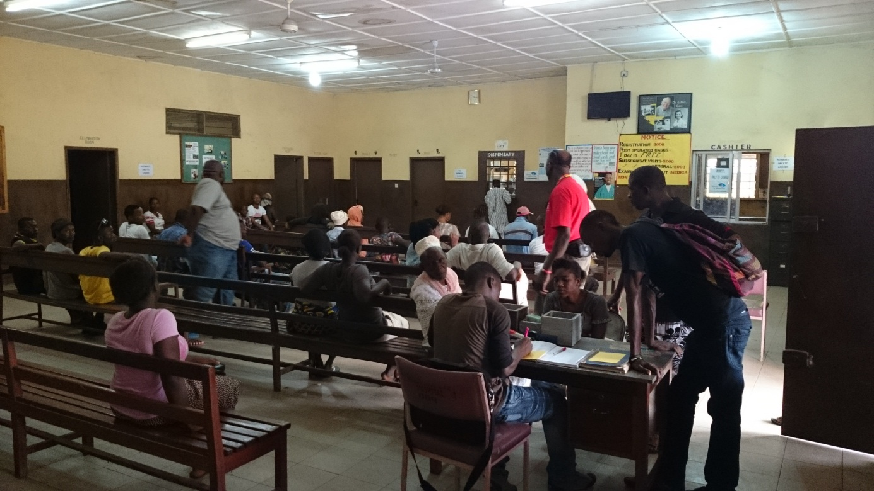
Picture 1: main waiting area of Kissy Eye Hospital before renovation (see the improvements in photo 4).
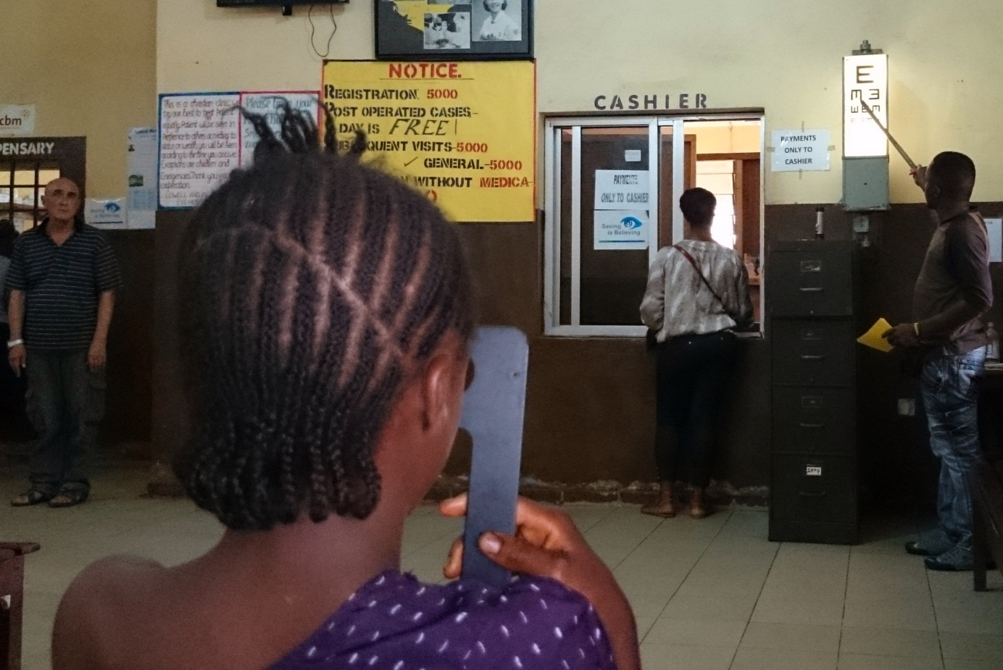
Picture 2: note the area in front of the cashier overloaded with difficult to read signs and posters before renovation (see the improvements in photo 3).
It was decided to identify urgent and especially low-budget access needs that the hospital was able to respond to first. Simple repainting of the walls and doors with high contrast colors enhanced identification of doors. Locally hand-made, affordable signs were designed to identify the most important information needed, e.g. location of examination rooms, pharmacy, optical shop etc. The result demonstrates that considering universal design principles could lead to a win-win situation for all people, not only those with vision impairment.
It also shows that striving for disability inclusive eye health is possible with a low budget (pictures 3 and 4 below).
For projects that strive to improve accessibility for people with disability, it is important to find strategies that are feasible and work in the local context. Further plans to strengthen disability inclusive practices beyond physical accessibility are already planned, with inclusion training and implementation of a low vision department at Kissy Eye Hospital.
We are also delighted that Kissy Eye Hospital continued to operate through the period of setbacks caused by Ebola in Sierra Leone and the wider West African region.
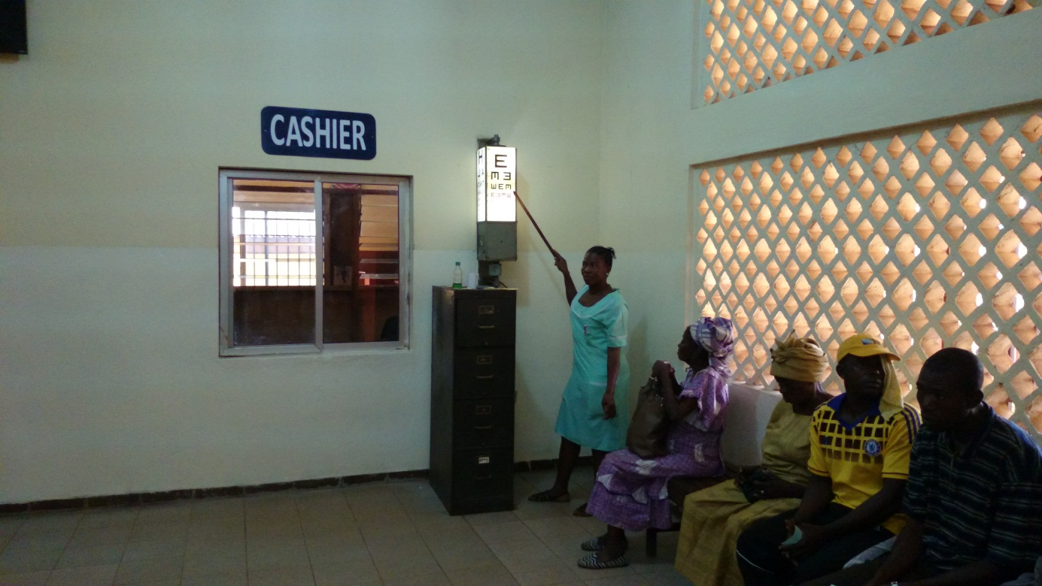
Picture 3: cashier area at Kissy Eye Hospital, after renovation
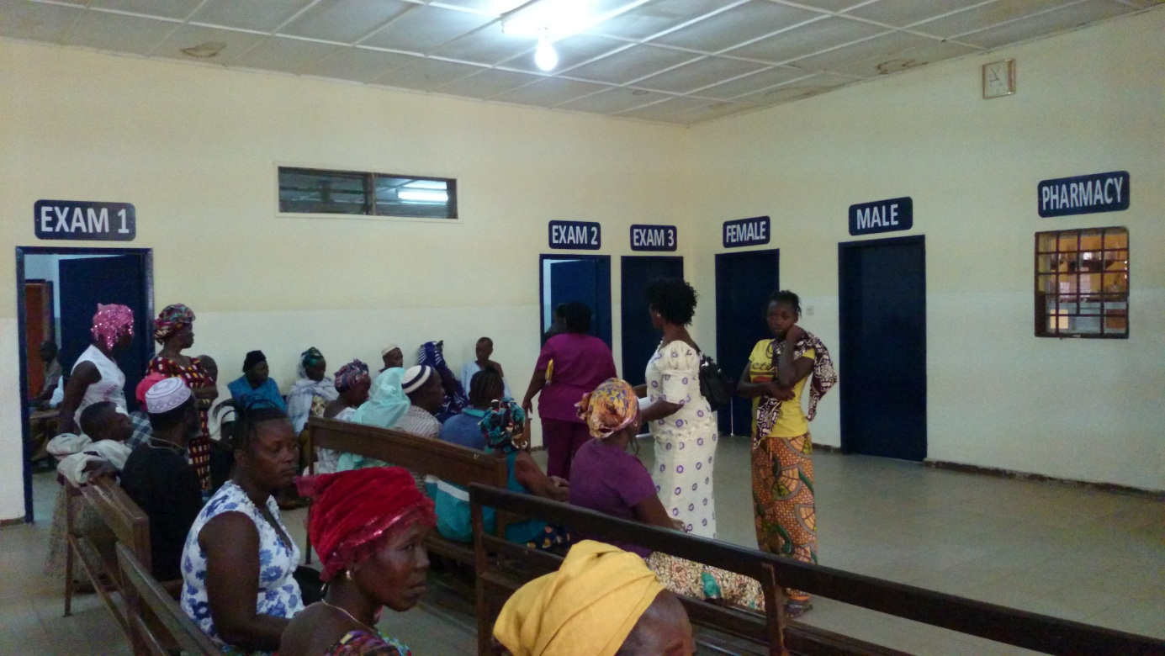
Picture 4: main waiting area of Kissy Eye Hospital after renovation

dlewis@cbm.org.au
http://www.cbm.org/Inclusive-Development-246768.php

