Silvia Soares - Gender and inclusion manager, rhto
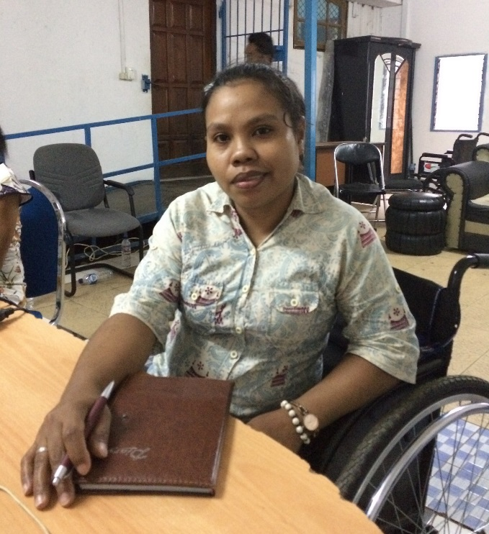
  - Timor-Leste
Silvia Soares works for the Timorese Disabled People’s Organisation Ra’es Hadomi Timor Oan (RHTO) as a Gender and Inclusion Manager in Dili, Timor-Leste. Silvia wants to show all people that women with disabilities have rights and that they can do something for their country.
Silvia contracted polio when she was three, and uses a wheelchair for mobility. When she was young her family worried about her future, and would tell her, “Oh Silvia, we don’t know what you want to do because your condition is like this”.
In 2008 Silvia began to volunteer with RHTO, wanting to support its work with people with disabilities. In 2010 she became Administration and Finance Officer, her first paid job. She was able to develop skills and experience in this position, and in 2012 became a Training and Inclusion Officer. Eventually she became the Gender and Inclusion Manager and is now a member of the RHTO Senior Management Team. In this role she works with partners to build and manage relationships, and represents RHTO nationally and internationally.
“You can create change, but you must be thinking change is possible and you must work hard.” – Silvia.
© CBM Australia
RHTO is supported with direct funding through the Australian Aid program, including through the Partnership for Human Development (PHD) program, and has partnerships with international NGOs. RHTO conducts training and capacity building on disability inclusion with agencies in Timor-Leste, and supports members through education scholarships and referrals to rehabilitation services.
In 2017, Silvia travelled to Geneva to contribute to monitoring for the United Nations Convention on the Rights of Persons with Disabilities. She also attended a Transforming Communities International (TCI) conference in Bali, representing the rights of people with psychosocial disabilities in Timor. She accompanied and supported RHTO members with psychosocial disabilities to attend the conference, and presented on the experiences of people with disabilities in Timor-Leste, and the discrimination and abuse that they face. She shared with TCI RHTO’s experience in working with and supporting women with psychosocial disabilities.
Working with RHTO has given Silvia opportunities, including the ability to save money and support herself. She has also been able to finish her university studies: in 2013 Silvia began studying international relations, despite facing physical barriers such as an inaccessible campus and classes being held on the top floor. By completing her studies, Silvia feels “this shows my family that yes, I can do something in my life”. She enjoys the opportunity to support the organisation’s work in advocating for the rights of people with disabilities to government and the wider community.
Silvia wants to demonstrate to all people, especially women with disabilities, that there is no reason to be shy: they can show the community and other people that they can do something with their lives.

